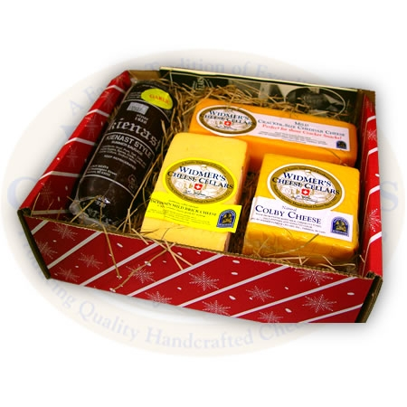
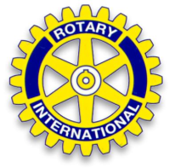Say Cheese and Donate
to High School Scholarships
Help the Madison East Monona Rotary Club raise money for local high school scholarships. For every cheese box you buy $7.75 goes directly to the scholarship fund. Gift boxes will be delivered in time for holiday gift giving. These gift boxes make a great gift for friends, neighbors and even your postal delivery person.
 |  | Assorted Gift Box  $25 | Aged Cheddar Sampler $25 | Total Boxes | Total Cost
Name | Phone | 8 oz each of 1-year sharp and 2 year aged cheddar, 8oz sharp cheese spread, 7 oz summer sausage | 8 oz. each of 1 year, 3 year and 5 year cheddar |  | $25 each box
Totals

Delivery on December 9th Each Rotarian will be responsible for making delivery of boxes sold.
Orders Due by November 25th Rotarian____________________________________________________________

